`

Simulation region

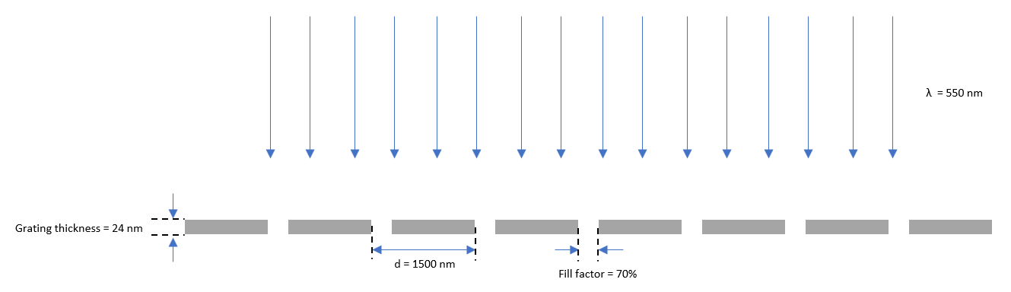

Image 1: Simulated model

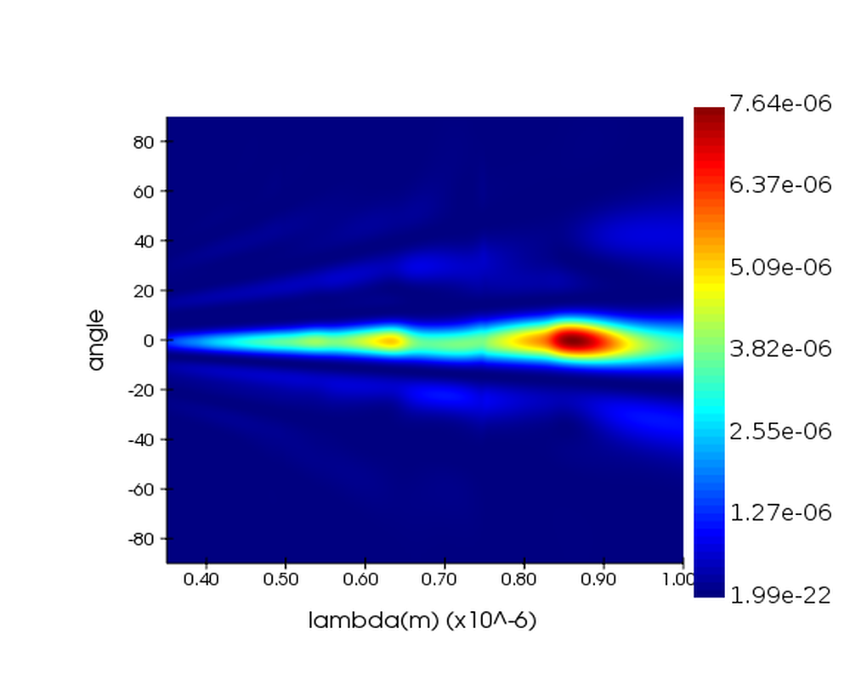

Image 2: Farfield simulation of the grating above

From the graph the various diffraction orders can be seen.

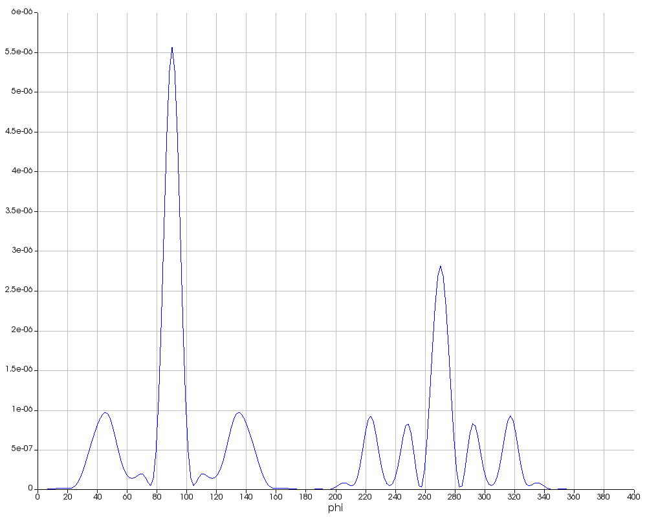

Graph 1: This graph shows the XY radiation pattern of the grating above.

The target wavelength is 0.51 microns. I have predicted the angles using $mλ=dsinθ$ where at m=1, d=1500nm and $λ$ = 510nm theta is 19.8 degrees and from the graph the main beam is at 90 degrees thus the first order is at 109.8. For m=2 the angle is 42.8 degrees and from the graph we can see a peak at 132.8 degrees and this shows that the results agree with the diffraction equation.